Test Case: tc001_SPX_Dev5_Crear_Nueva_Linea_Requisicion_Spot_Tipo_Cobro_CC
Step 1 - Enter username and password and click to button Enter : Credentials Entered
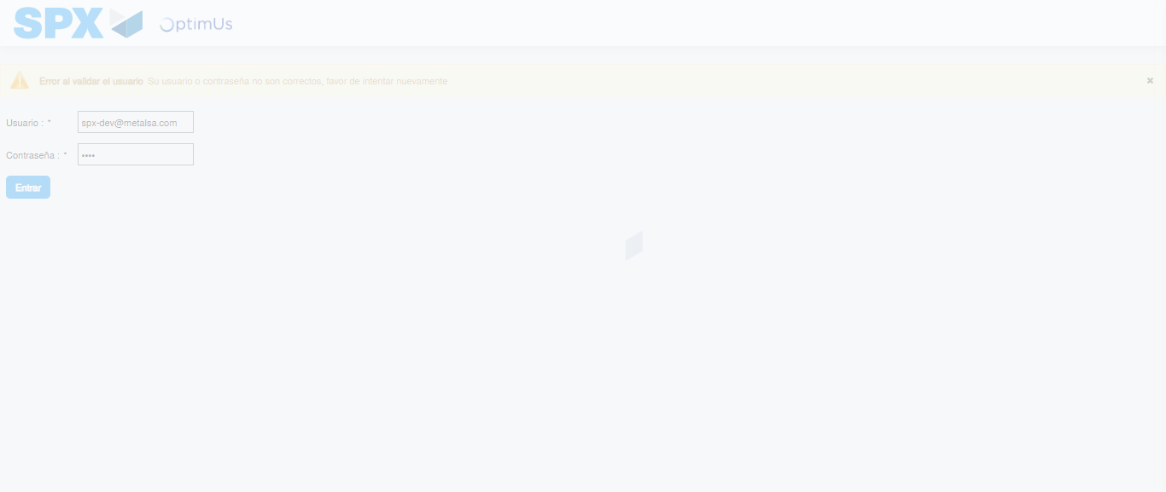Image file-name: QC_Testing-tc001_SPX_Dev5_Crear_Nueva_Linea_Requisicion_Spot_Tipo_Cobro_CC-1790177246766

Step 2 - Select to UEN and Access to Spot Buy Requisitions : UEN Correctly selected and Correct access
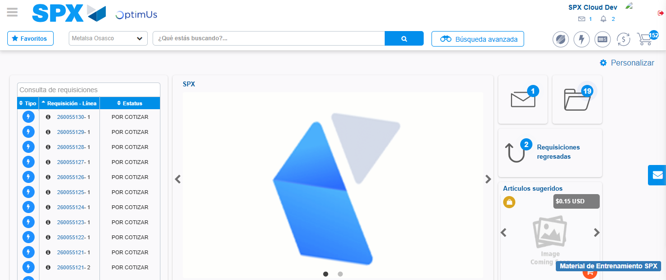Image file-name: QC_Testing-tc001_SPX_Dev5_Crear_Nueva_Linea_Requisicion_Spot_Tipo_Cobro_CC-1790177283842

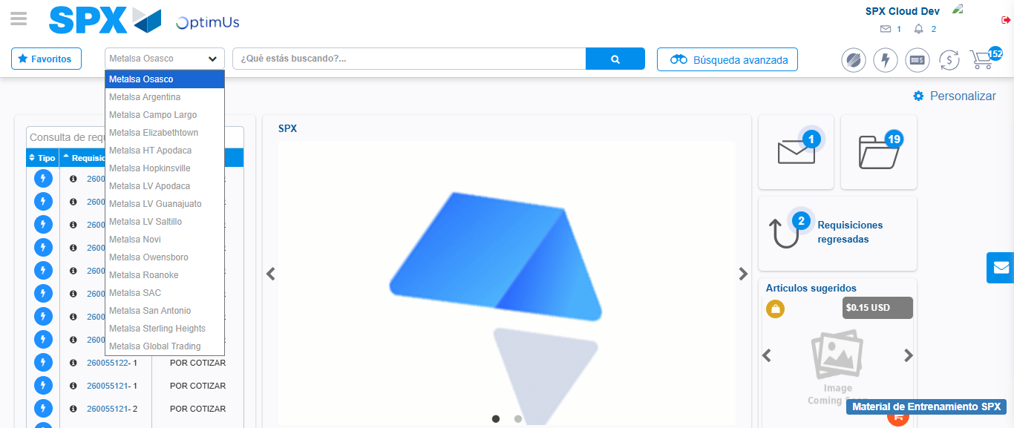Image file-name: QC_Testing-tc001_SPX_Dev5_Crear_Nueva_Linea_Requisicion_Spot_Tipo_Cobro_CC-1790177284632

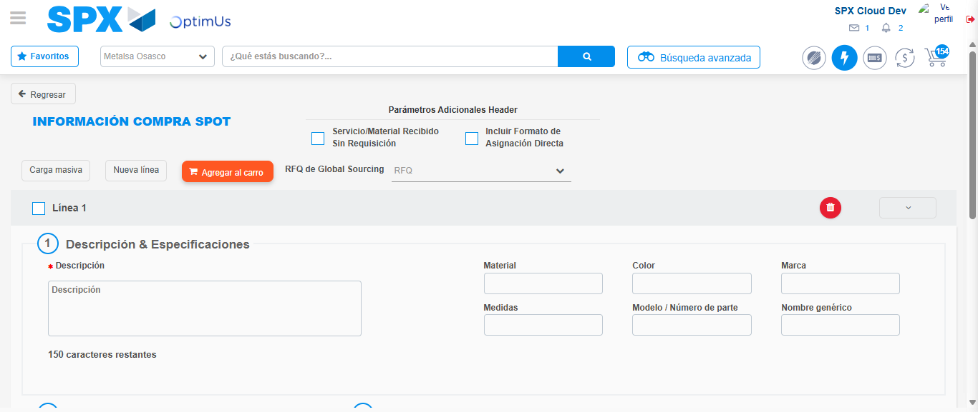Image file-name: QC_Testing-tc001_SPX_Dev5_Crear_Nueva_Linea_Requisicion_Spot_Tipo_Cobro_CC-1790177289898

Step 3 - Data Capture Spot Buy Requisition: Data captured correctly
Image file-name: QC_Testing-tc001_SPX_Dev5_Crear_Nueva_Linea_Requisicion_Spot_Tipo_Cobro_CC-1790177290242

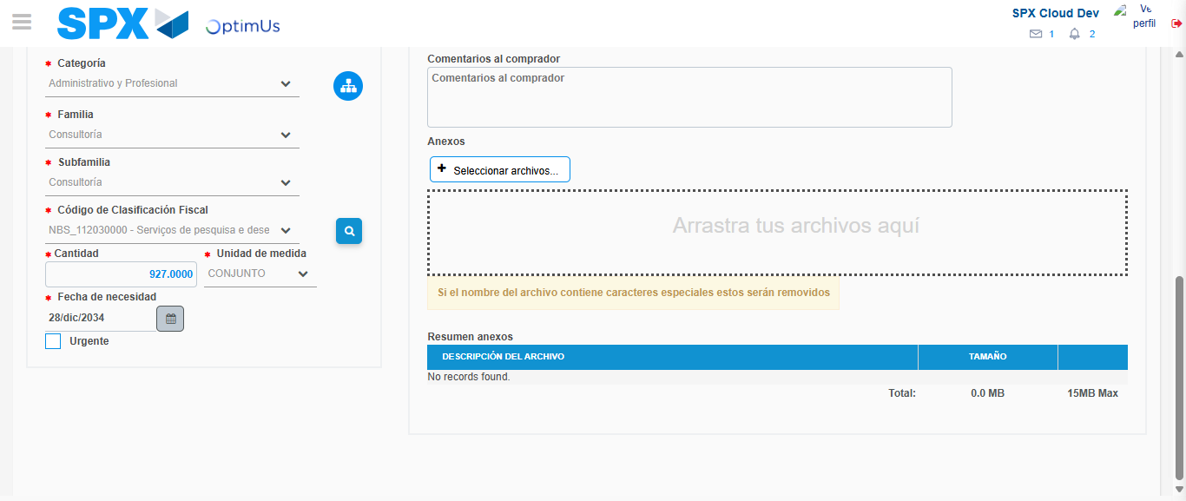Image file-name: QC_Testing-tc001_SPX_Dev5_Crear_Nueva_Linea_Requisicion_Spot_Tipo_Cobro_CC-1790177316749

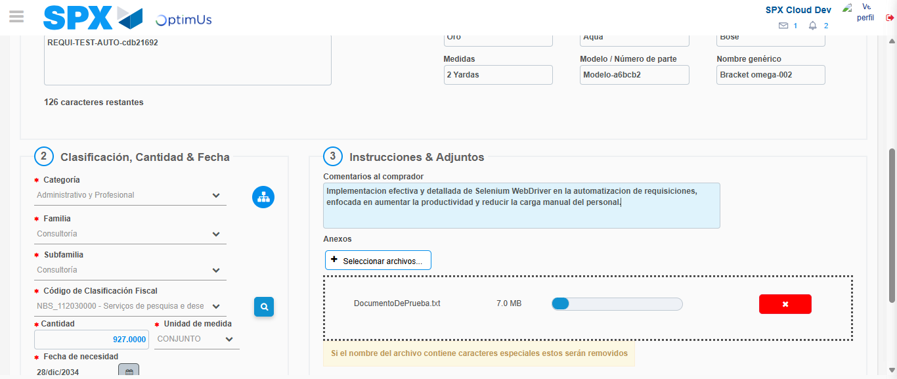Image file-name: QC_Testing-tc001_SPX_Dev5_Crear_Nueva_Linea_Requisicion_Spot_Tipo_Cobro_CC-1790177317591

Step 4 - Add new line and data capture second line: Line add correctly
Image file-name: QC_Testing-tc001_SPX_Dev5_Crear_Nueva_Linea_Requisicion_Spot_Tipo_Cobro_CC-1790177290242

Image file-name: QC_Testing-tc001_SPX_Dev5_Crear_Nueva_Linea_Requisicion_Spot_Tipo_Cobro_CC-1790177316749

Image file-name: QC_Testing-tc001_SPX_Dev5_Crear_Nueva_Linea_Requisicion_Spot_Tipo_Cobro_CC-1790177317591

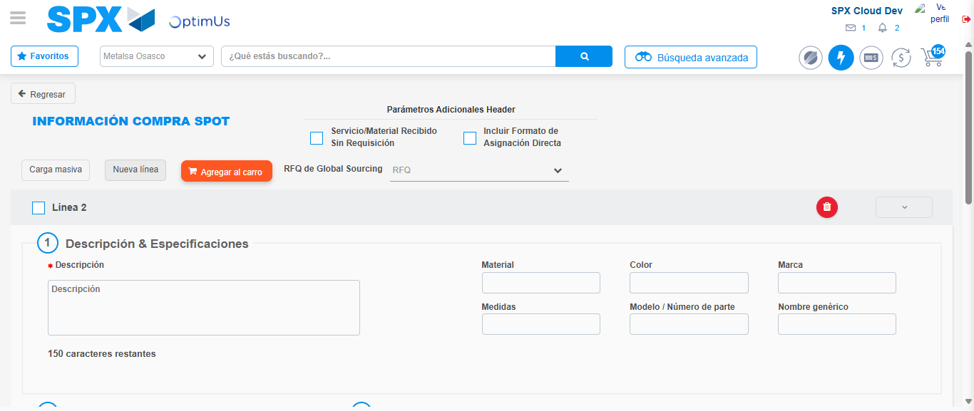Image file-name: QC_Testing-tc001_SPX_Dev5_Crear_Nueva_Linea_Requisicion_Spot_Tipo_Cobro_CC-1790177319936

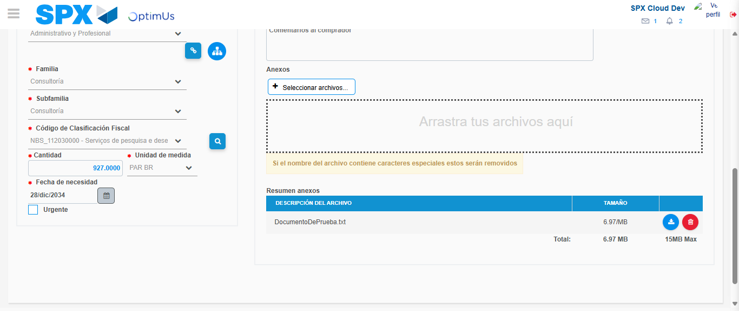Image file-name: QC_Testing-tc001_SPX_Dev5_Crear_Nueva_Linea_Requisicion_Spot_Tipo_Cobro_CC-1790177338124

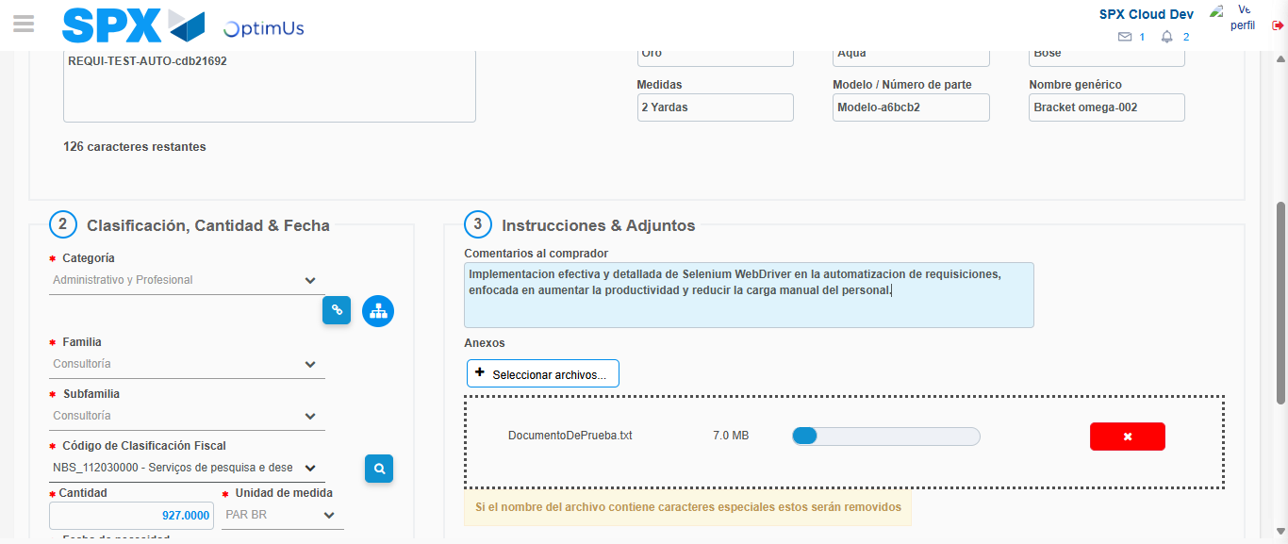Image file-name: QC_Testing-tc001_SPX_Dev5_Crear_Nueva_Linea_Requisicion_Spot_Tipo_Cobro_CC-1790177339143

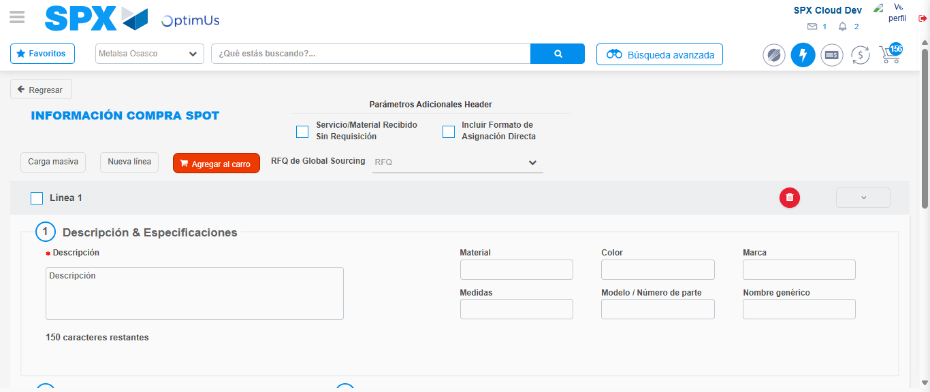Image file-name: QC_Testing-tc001_SPX_Dev5_Crear_Nueva_Linea_Requisicion_Spot_Tipo_Cobro_CC-1790177354248

Step 8 - Return to Main Page SPX : Return to Main Page SPX
Image file-name: QC_Testing-tc001_SPX_Dev5_Crear_Nueva_Linea_Requisicion_Spot_Tipo_Cobro_CC-1790177283842

Image file-name: QC_Testing-tc001_SPX_Dev5_Crear_Nueva_Linea_Requisicion_Spot_Tipo_Cobro_CC-1790177284632

Image file-name: QC_Testing-tc001_SPX_Dev5_Crear_Nueva_Linea_Requisicion_Spot_Tipo_Cobro_CC-1790177289898

Image file-name: QC_Testing-tc001_SPX_Dev5_Crear_Nueva_Linea_Requisicion_Spot_Tipo_Cobro_CC-1790177356503

Image file-name: QC_Testing-tc001_SPX_Dev5_Crear_Nueva_Linea_Requisicion_Spot_Tipo_Cobro_CC-1790177356677

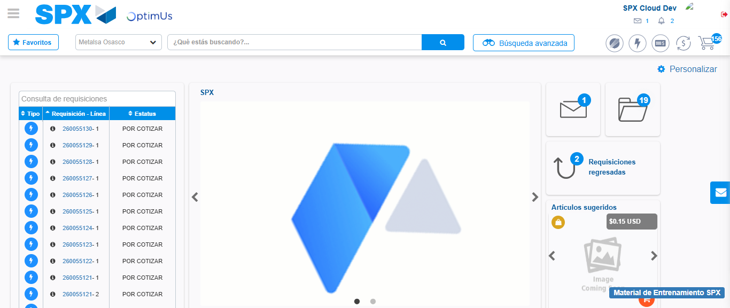Image file-name: QC_Testing-tc001_SPX_Dev5_Crear_Nueva_Linea_Requisicion_Spot_Tipo_Cobro_CC-1790177378236

Step 9 - Log Out : Log Out SPX
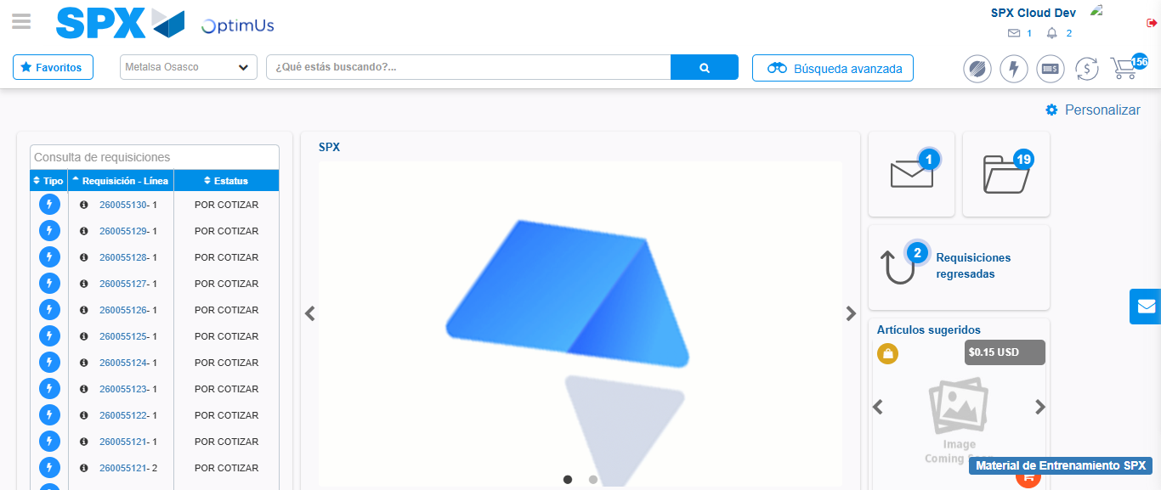Image file-name: QC_Testing-tc001_SPX_Dev5_Crear_Nueva_Linea_Requisicion_Spot_Tipo_Cobro_CC-1790177378602

